**Link to my profile**: <https://learn.microsoft.com/en-us/users/mohammadyehya-5844/>

**Link to my transcript**: <https://learn.microsoft.com/en-us/users/mohammadyehya-5844/transcript/dz3oqfn9166yymw>

**Screenshots of individual module completion**:

Part 1 Module 1

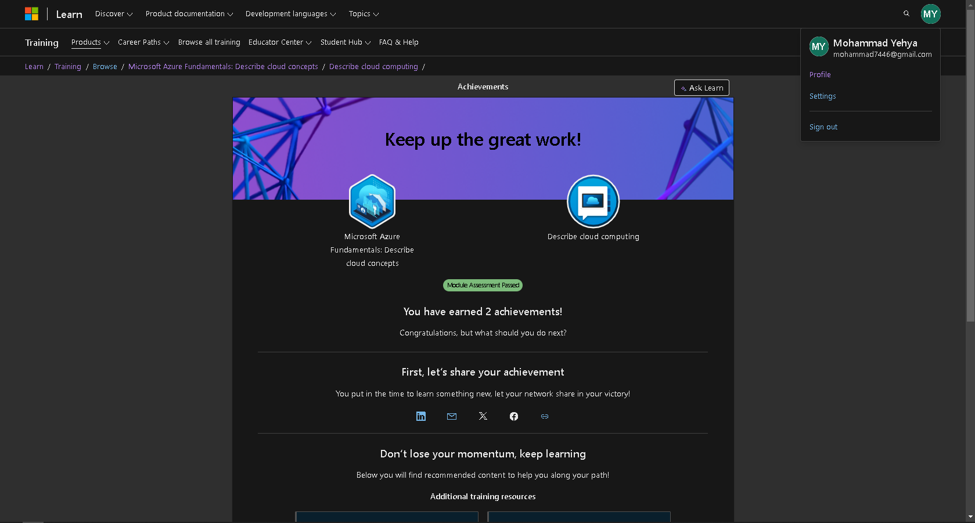

Part 1 Module 2

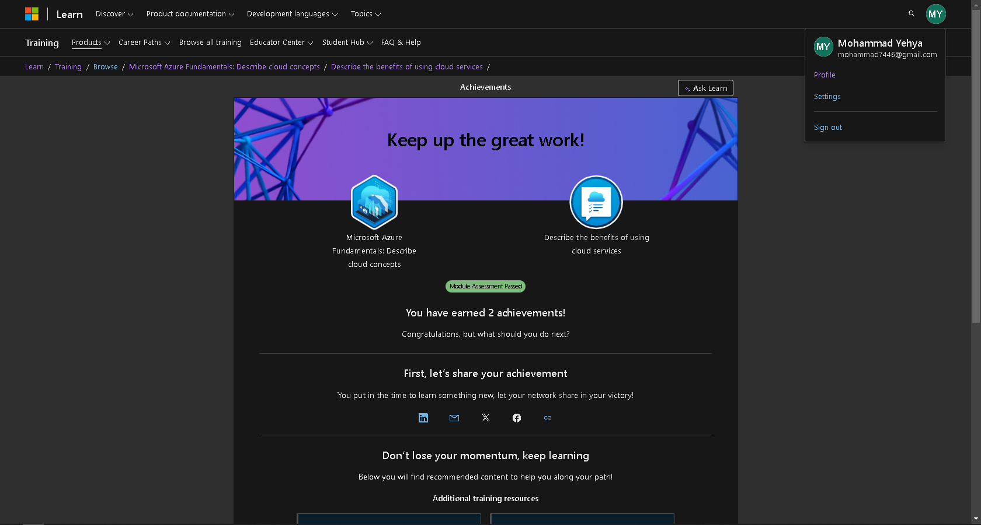

Part 1 Module 3

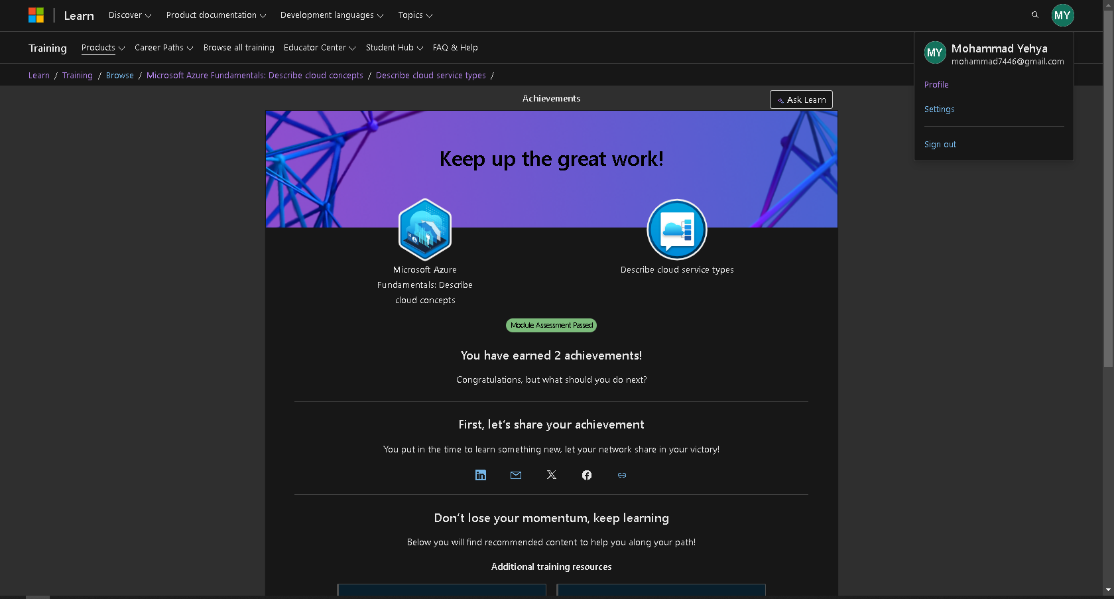

Part 2 Module 1

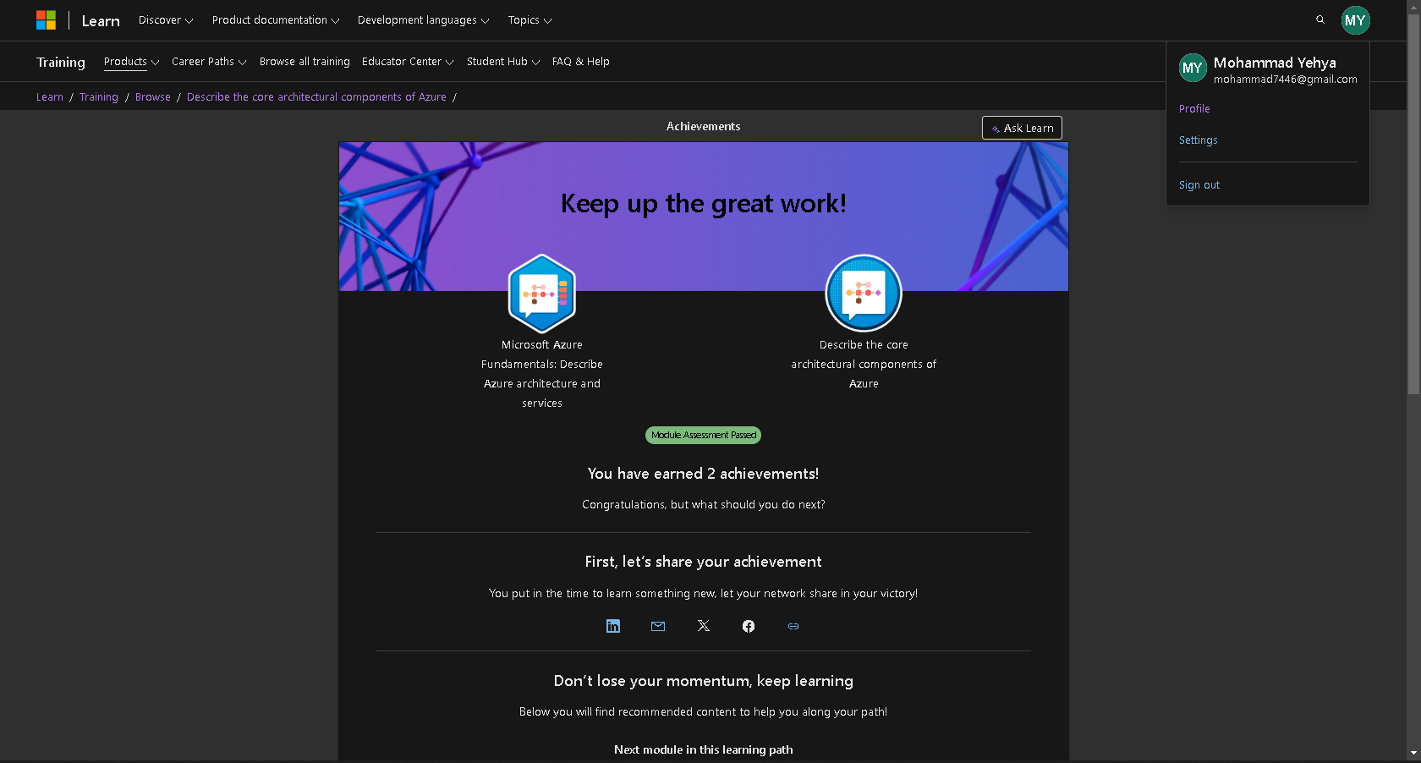

Part 2 Module 2

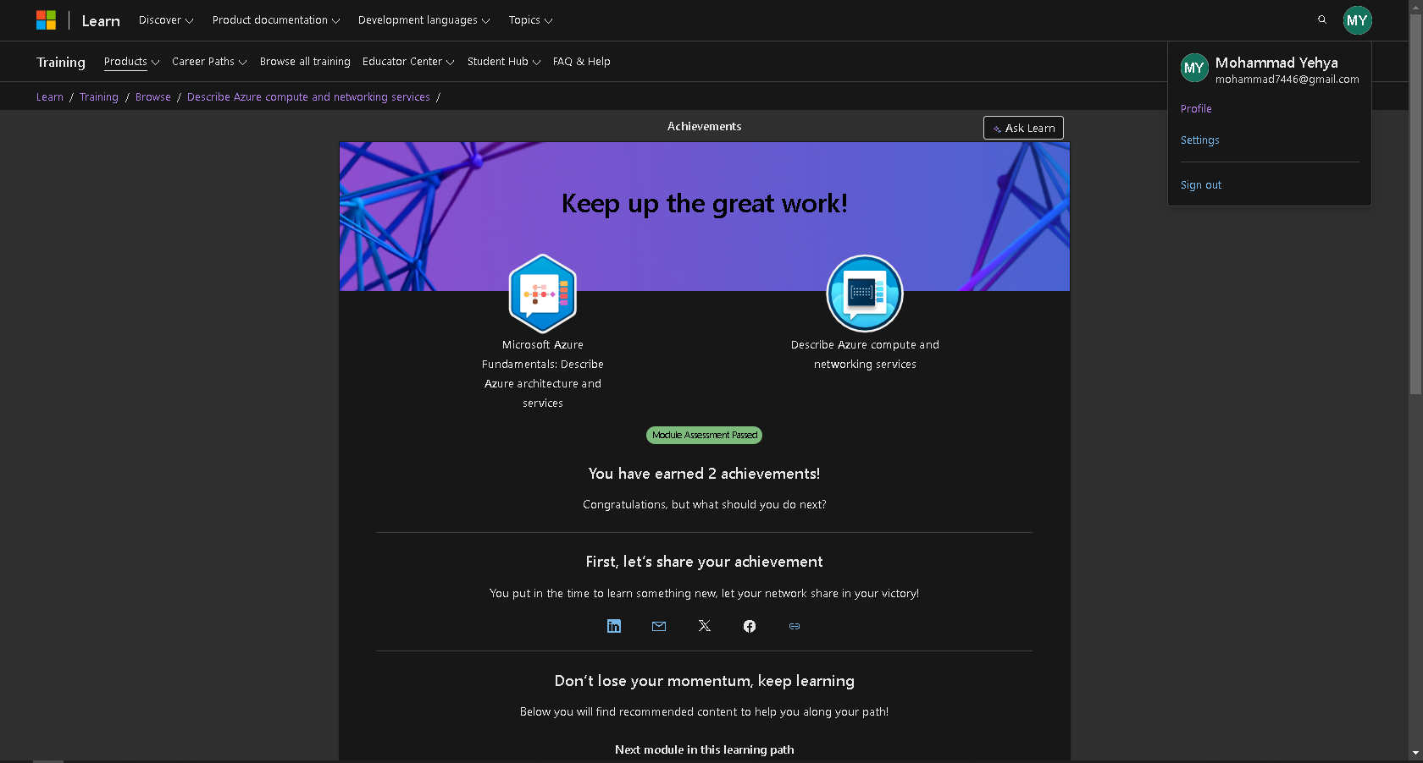

Part 2 Module 3

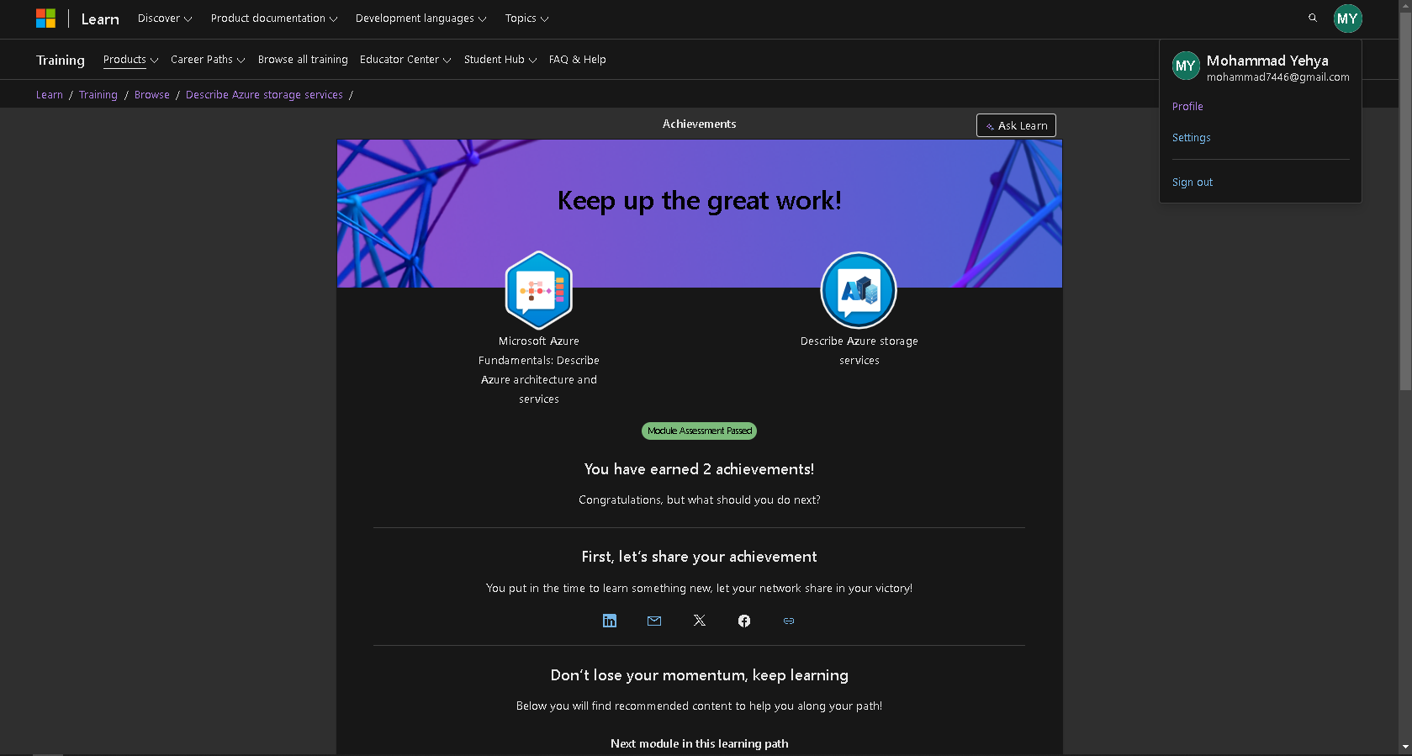

Part 2 Module 4

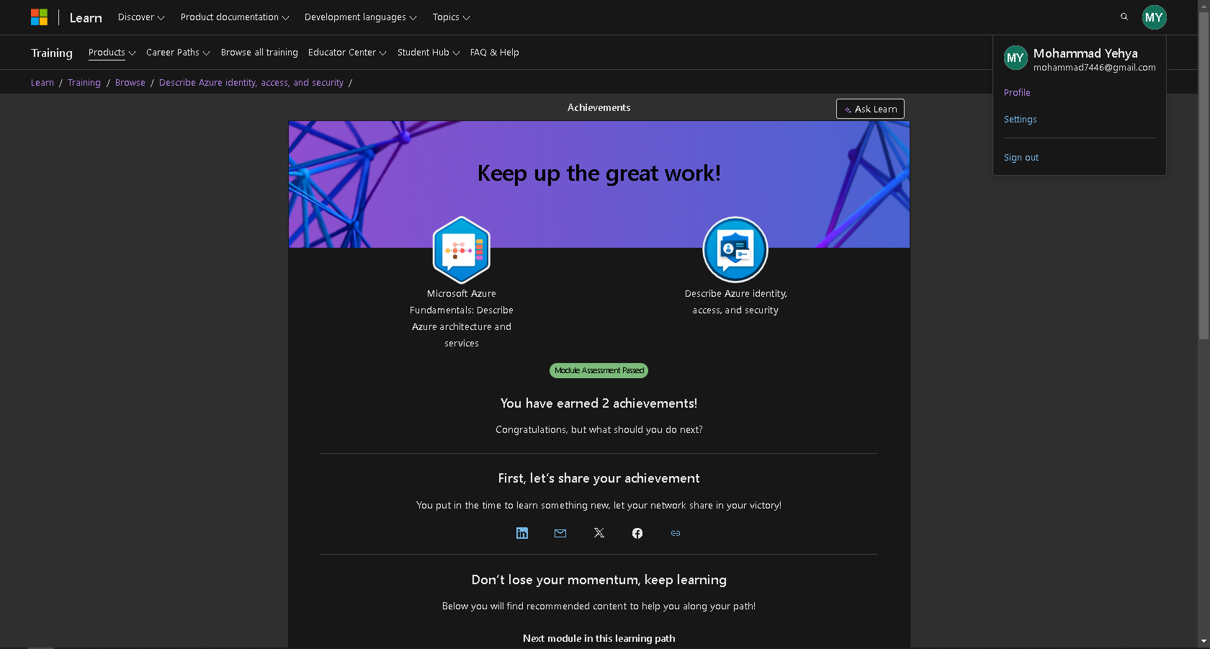

Part 3 Module 1

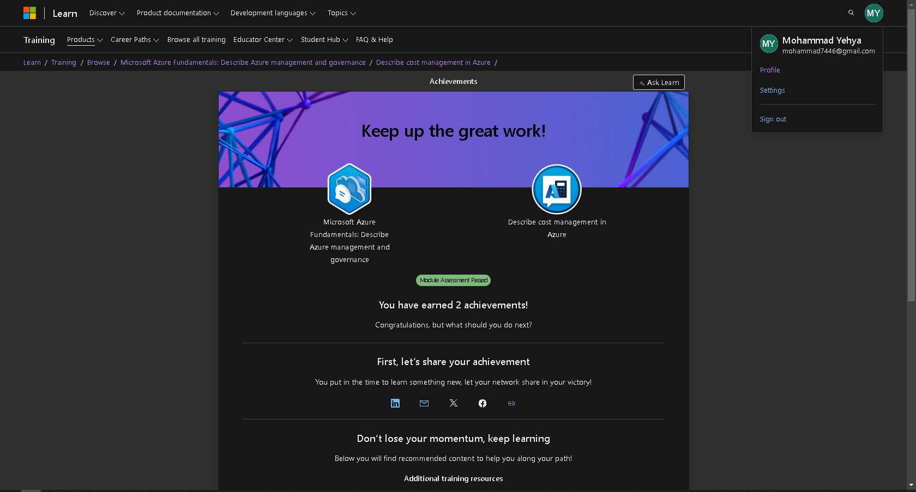

Part 3 Module 2

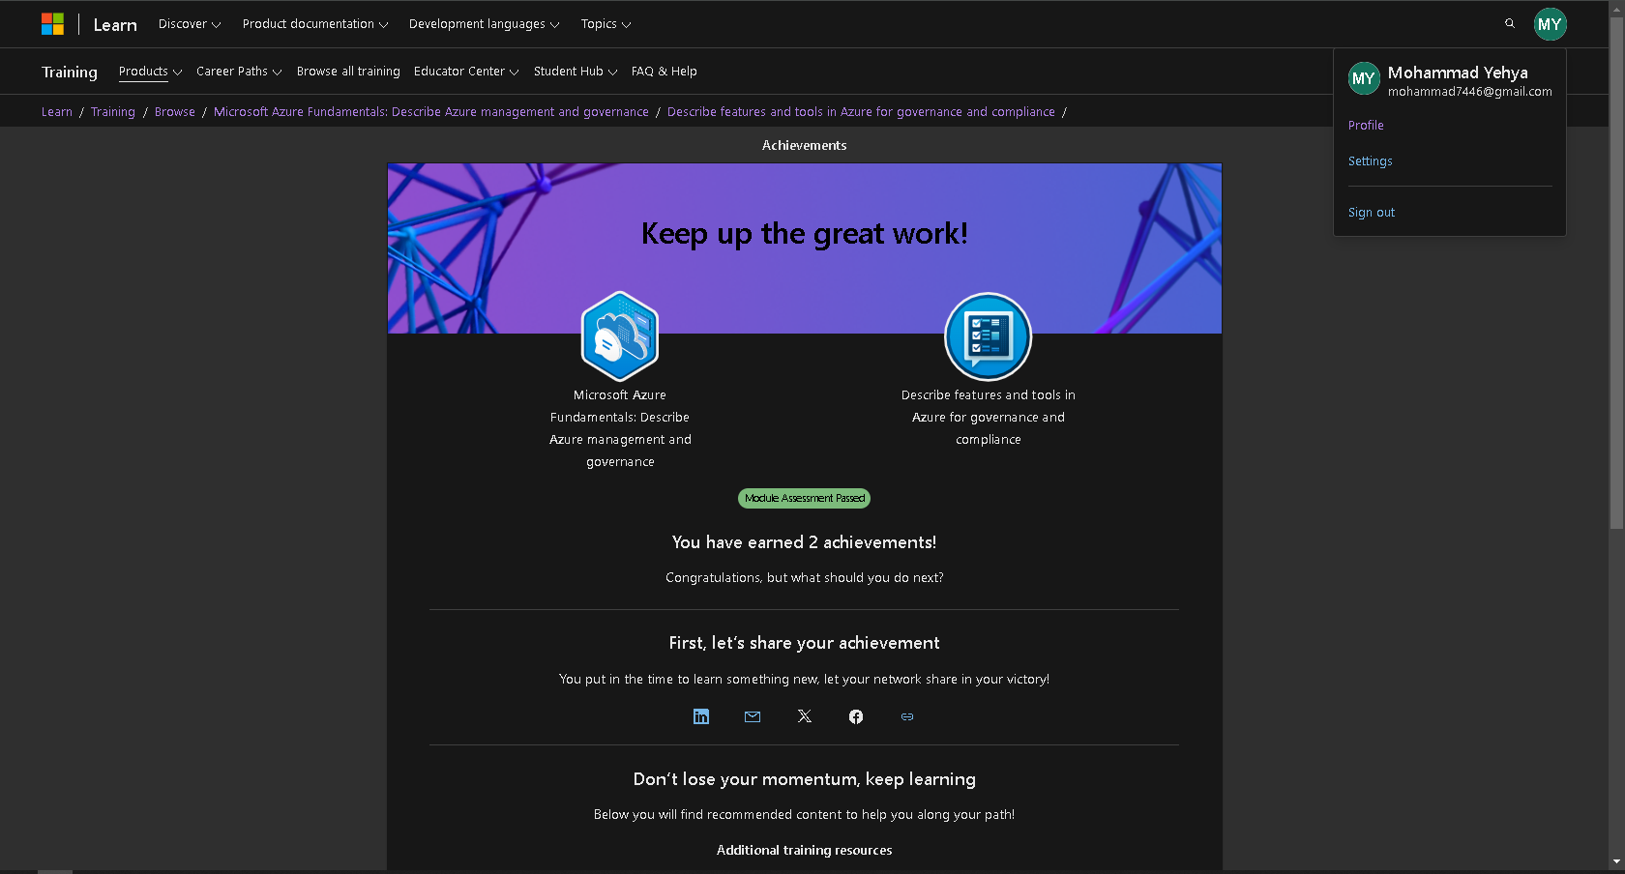

Part 3 Module 3

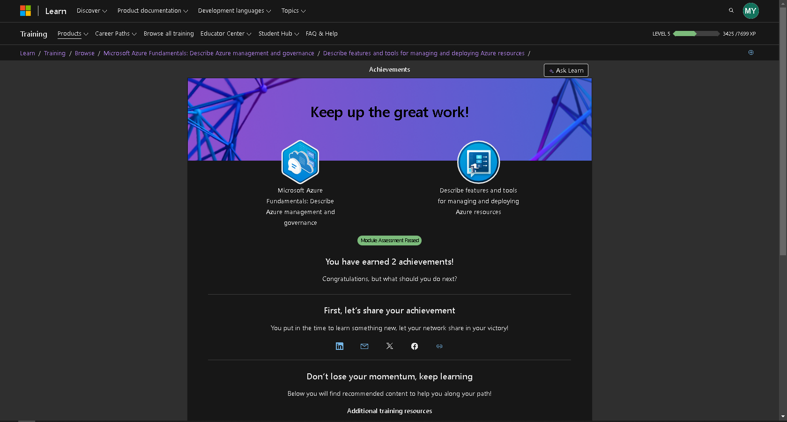

Part 3 Module 4

